**National University of Computer & Emerging Sciences**

**Karachi Campus**



**Project Report**

**Numerical Computing Project**

**[]**

**Course Teacher:**

**Muhammad Jamil Usmani**

**Group Members:**

**Zaid Bin Shahab 19K-1512**

**Saud Ahmed Abbasi 19K-0229  
Umer Ahmed 19K-0181**

Contents

**Sympy Functions Used:** 3

**Chapter#2-Solutions of Equations in One Variable** 5

Bisection, Regular Falsi, Newton, Secant: 5

Fixed Point Iteration: 9

**Chapter#3-Interpolation and Polynomial Approximation** 10

Lagrange Method : 10

Forward Divided Difference: 13

Forward Simple Difference: 15

Backward Divided Difference: 17

Backward Simple Difference: 19

Center Divided Difference: 21

**Chapter#4-Numerical Differentiation and Integration** 23

Three point Formula: 23

Five point formulas: 25

Trapezoid: 29

Simpson’s 1/3: 30

Using Simpson’s 3/8 (NO QUESTIONS FOUND IN BOOK, APPLYING ON SIMPSON’S 1/3 QUESTION): 31

Midpoint Rule: 32

**Chapter#5 -Initial-Value Problems for Ordinary Differential Equations** 34

Euler’s Method: 34

Modified Euler: 36

Huen Method: 38

RK4 Method: 40

# **Sympy Functions Used:**

**Important library functionality imported:**

from sympy.parsing.sympy_parser import (parse_expr, standard_transformations, implicit_multiplication_application)

Allows a slightly relaxed syntax.

* Parentheses for single-argument method calls are optional.
* Multiplication is implicit.
* Symbol names can be split (i.e. spaces are not needed between symbols).
* Functions can be exponentiated.

Function parse_expr() returns an expression of the Type that sympy supports (such as “2x-2” would have the type **sympy.core.add.Add** after passing through the parser), we can also add local_dict functions that can be detected by the parser (such as sin/cos/tan functions or log functions can be passed directly in the argument of the parser)

For example:  
 Function = parse_expr(expression, local_dict={"log": lambda x: sympy.log(x, 10), transformations=(standard_transformations + (implicit_multiplication_application,)))

Where **expression** denotes string input of function, **local_dict** are the functions we want to have detected while parsing and are replaced by their in-code counterparts, and **transformations** deals with possible functionalities that can be applied such as implicit multiplication (i.e. 2x will be perceived as 2*x automatically)

All the symbols are detected and stored in a list, here’s an example:  
 all_symbols = [str(x) for x in **Function**.atoms(Symbol)]

Where **Function** is the function that exists after being string has been parsed by going through the function parse_expr().

All symbols are replaced with their values, here’s an example:  
 for i, item in enumerate(all_symbols):

key = all_symbols[i]

value = limit_val

symbol_vals[key] = value

And then substituted, here’s an example:  
 Function = Function.subs(symbol_vals)

When all the values have been successfully substituted into the parsed sympy type function, we can now evaluate it using evalf(), and then return the value, here’s an example:  
 return float(Function.evalf())

# **Chapter#2-Solutions of Equations in One Variable**

## Bisection, Regular Falsi, Newton, Secant:

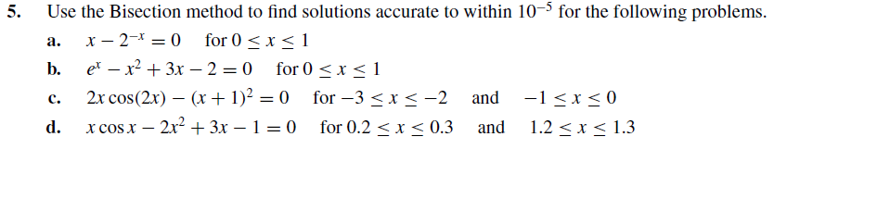

Part Q5c)  
All Methods Applied (i.e. Bisection, Regular Falsi, Newton, Secant)

**Input:**

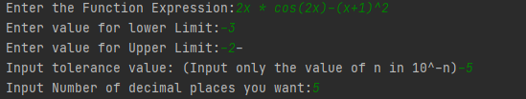

**Output:**

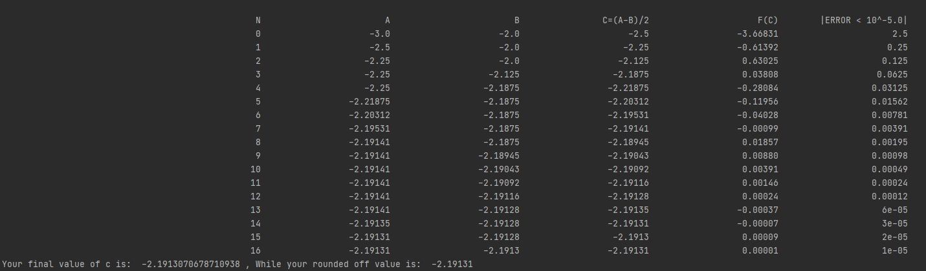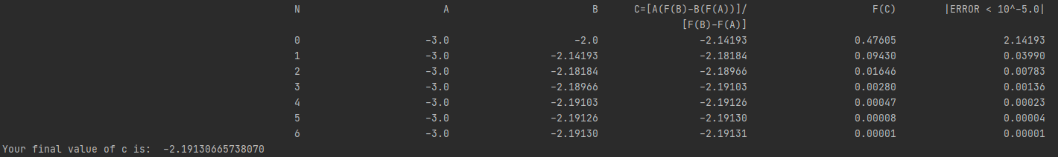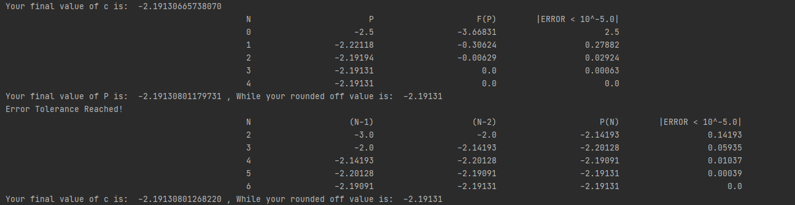

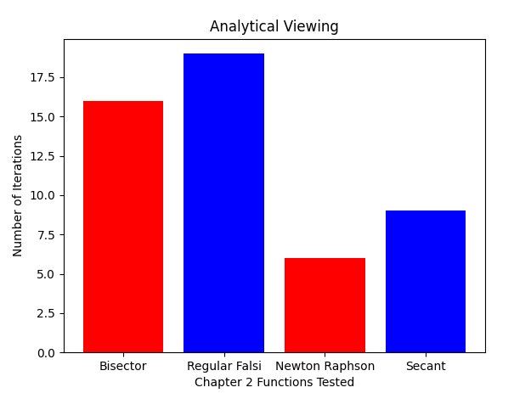

Answer from book matching:  
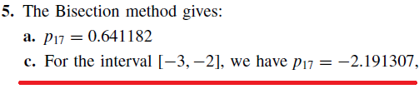

Q5d)  
All Methods Applied (i.e. Bisection, Regular Falsi, Newton, Secant)

**Input:  
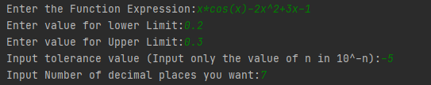**

**Output:  
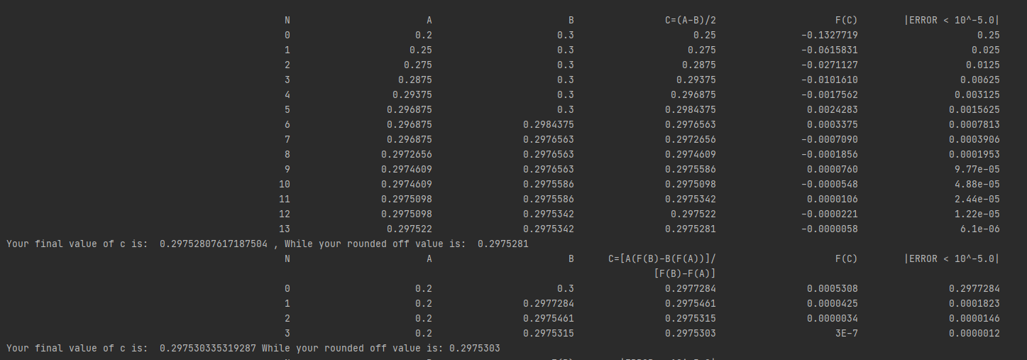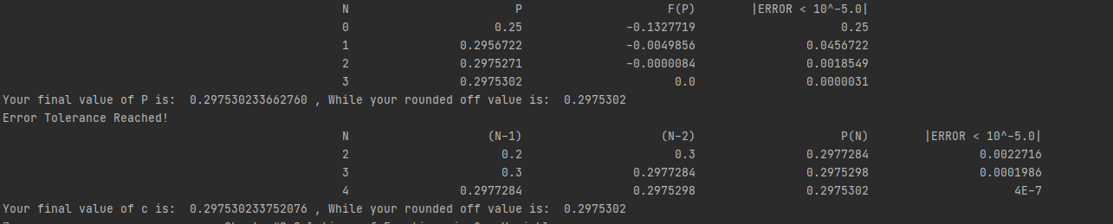**

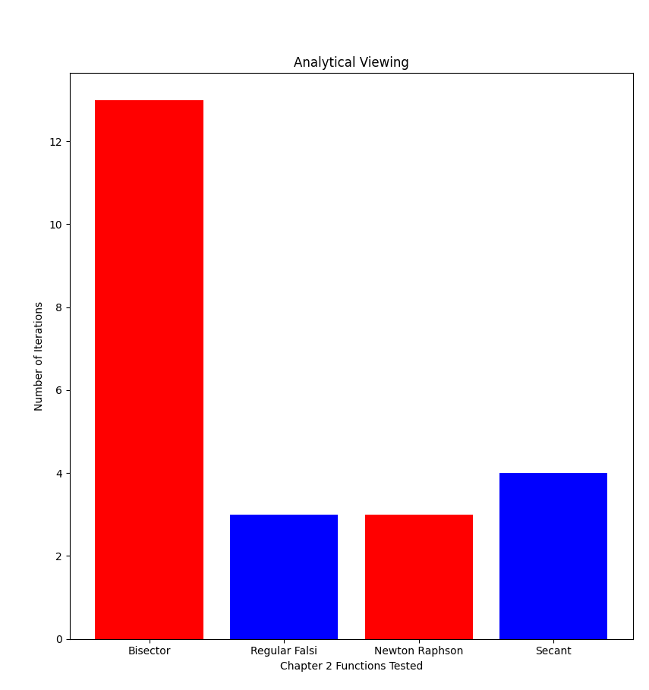

Answer from book matching:



## Fixed Point Iteration:



**Inputs:**

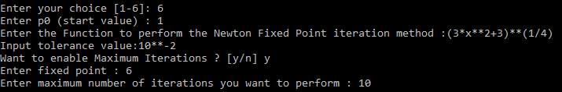

**Outputs:**

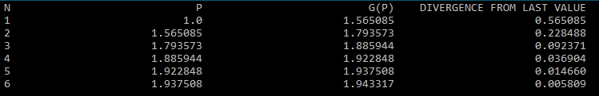





**Inputs:**

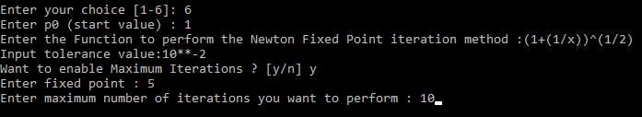

**Output:**

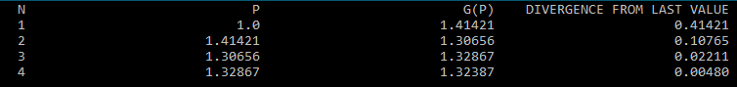



# **Chapter#3-Interpolation and Polynomial Approximation**

Lagrange Method : 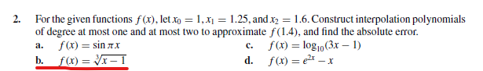

**Q2b) using n = 2**

**Input:**

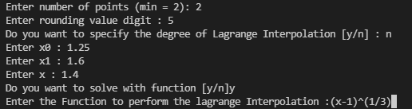

**Output:**

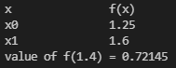

**Verification:**

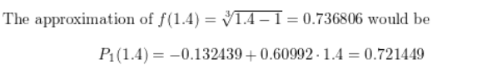

**Q2b) using n = 3**

**Input:**

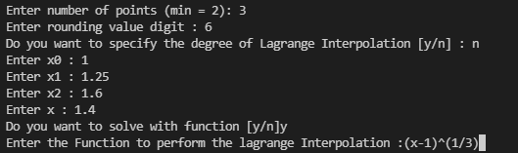

**Output:**

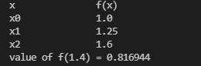

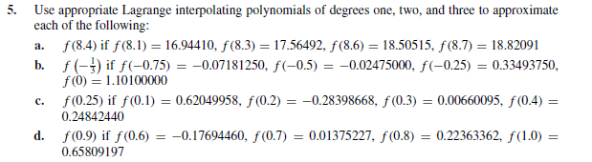

**Q5a) Using Lagrange with n = 3**

**Input:**

**(Upper values)**

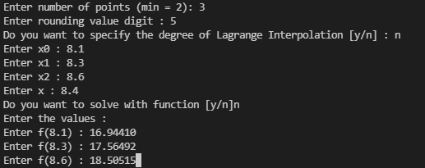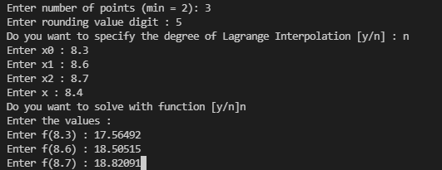**Lower value**

**Output:**

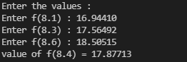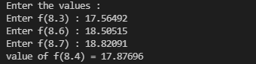

**Verification:**

** from book**

## Forward Divided Difference:

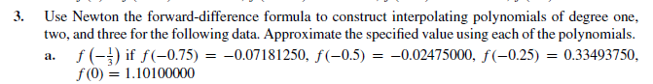

**Input:**

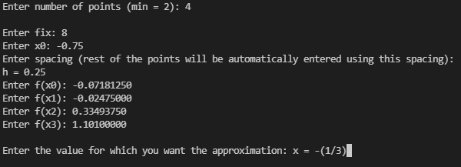

**Output:**

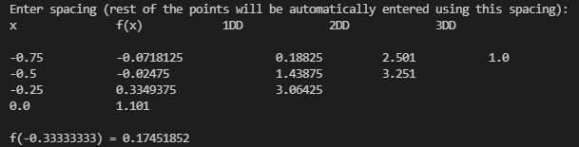

**Verification:**

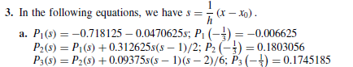**🡨-**

**Another Forward divided difference example:**

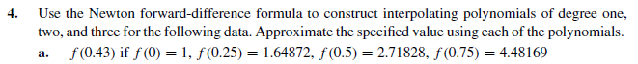

**Input:**

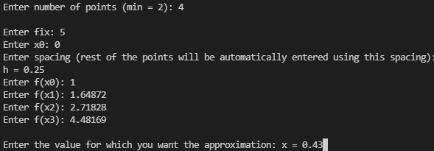

**Output:**

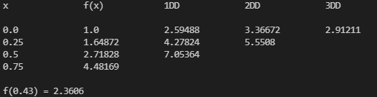

**Verification:**

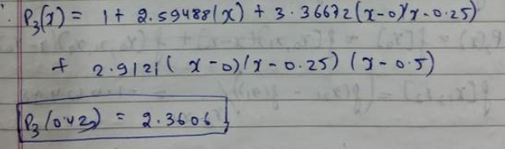

## Forward Simple Difference:

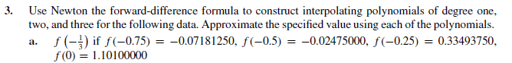

**Input:**



**Output:**

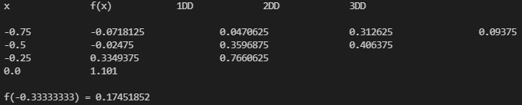

**Verification:**

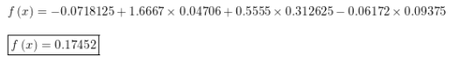

**Another Forward Simple Difference Example:**



**Input:**



**Output:**

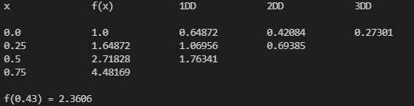

**Verification:**



## Backward Divided Difference:

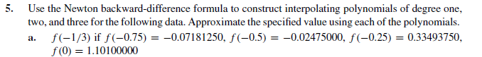

**Input:**

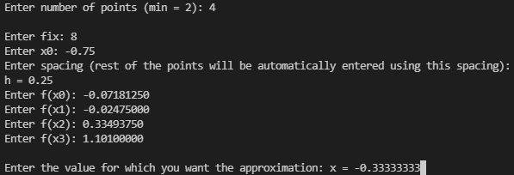

**Output:**

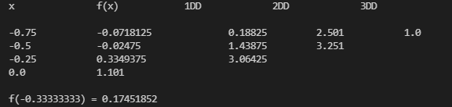

**Verification:**

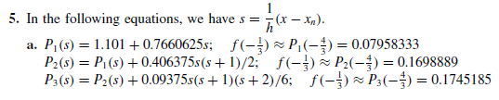**🡨**

**Another Backward Divided Difference example:**

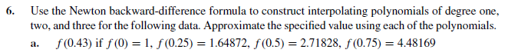

**Input:**

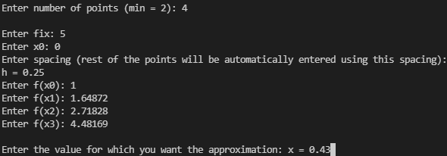

**Output:**

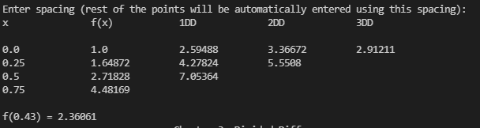

**Verification:**

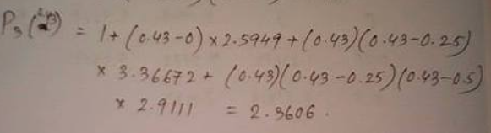

## Backward Simple Difference:



**Input:**



**Output:**

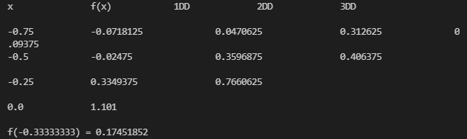

**Verification:**



**Another example of Backward Simple Difference:**



**Input:**



**Output:**

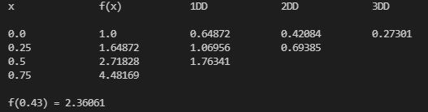

**Verification:**



## Center Divided Difference:

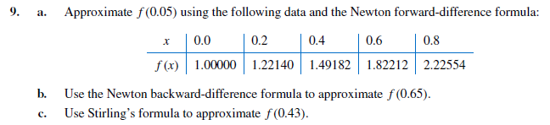

**9c)**

**Input:**

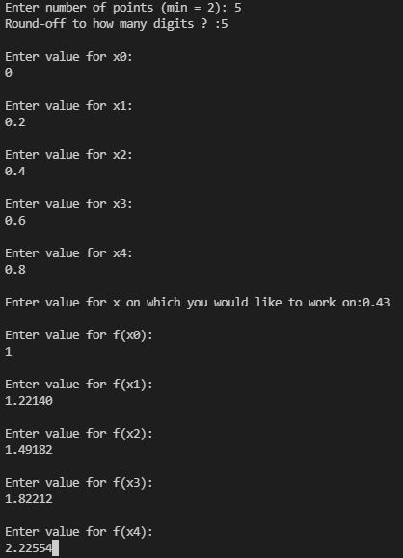

**Output:**

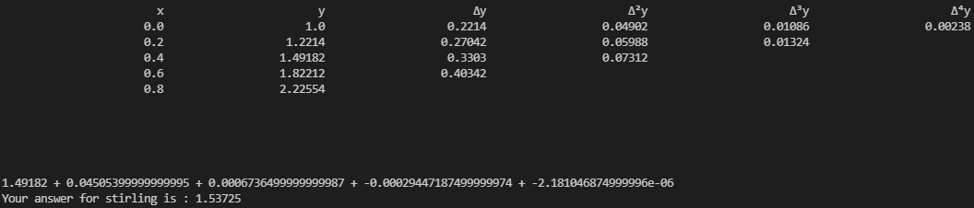

**Verification:**

**🡨 from book**

# **Chapter#4-Numerical Differentiation and Integration**

## Three point Formula:

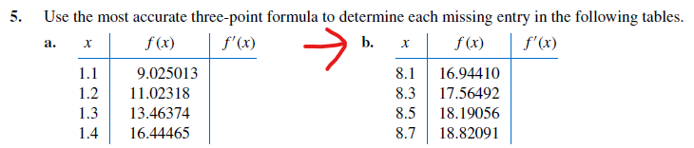

**Input:**

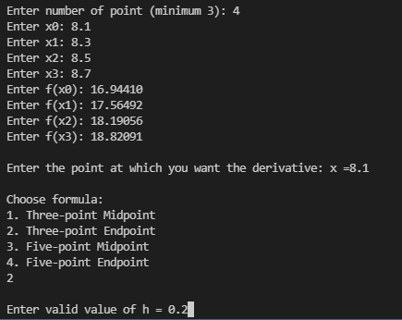

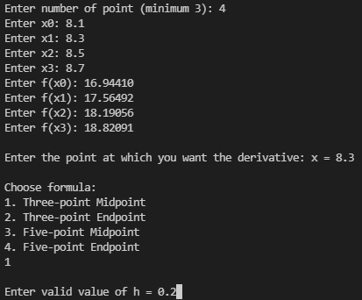

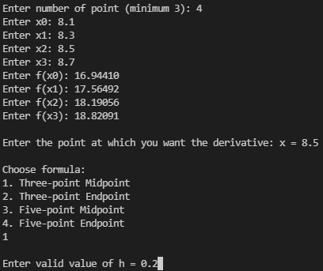

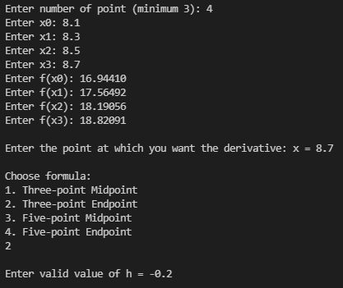

**Output:**









**Verification:**

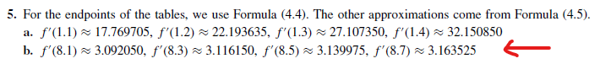

## Five point formulas:

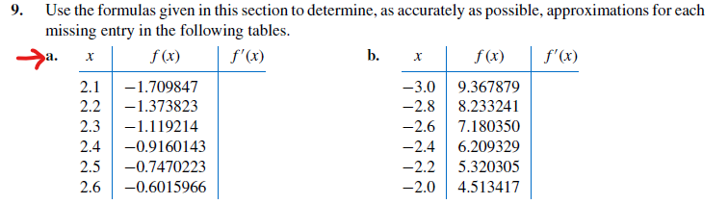

**Input:**

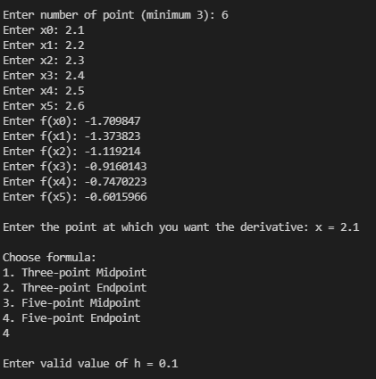

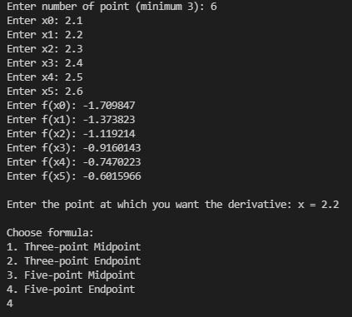

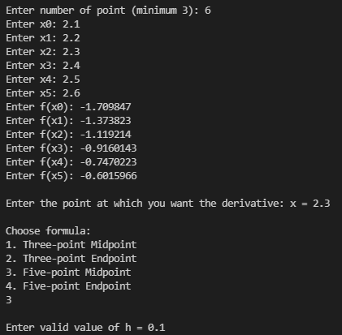

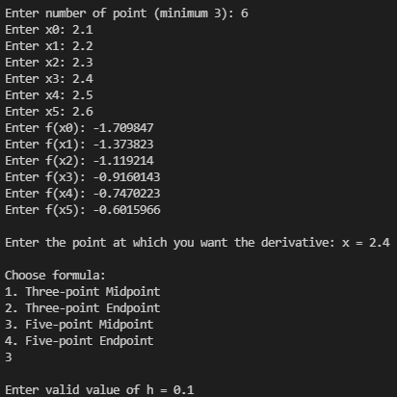

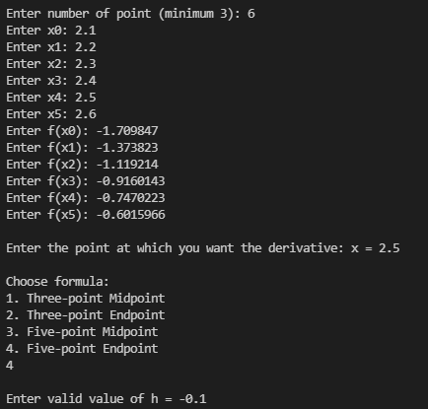

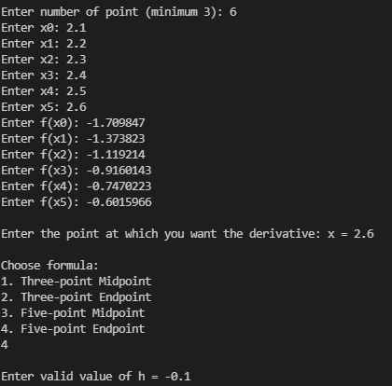

**Output:**













**Verification:**



## Trapezoid:

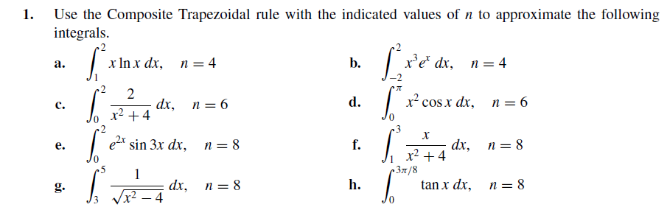

**Q1h)   
Input:**

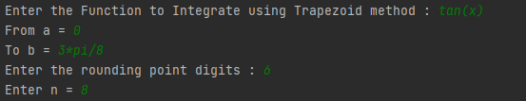

**Output:**



**Verification:**

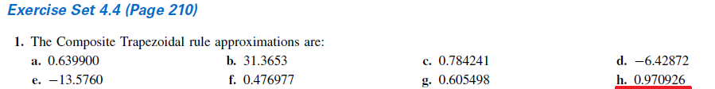

**Q1g)**

**Input:**

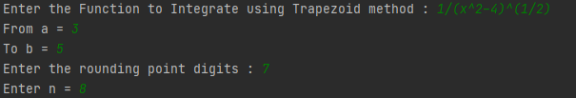

**Output:**



**Verification:**

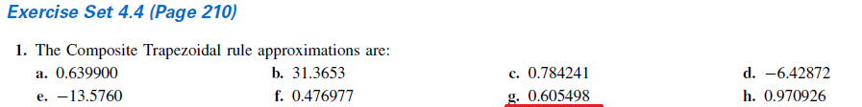



## Simpson’s 1/3:



**Q3b)**

**Input:**

**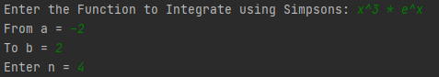  
Output:**



**Verification:**

**  
Q3e)**

**Input:**

**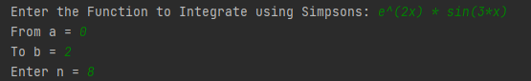  
Output:  
**

**Verification:**



## Using Simpson’s 3/8 (NO QUESTIONS FOUND IN BOOK, APPLYING ON SIMPSON’S 1/3 QUESTION):

**Q3b)**

**Input:**

**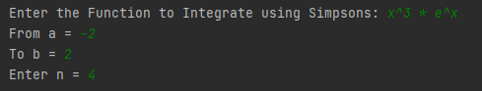  
Output:**



**Verification:**



**Q3e)**

**Input:**

**  
Output:  
**

**Verification:**



## Midpoint Rule:

**Q5c)**

**Input:**

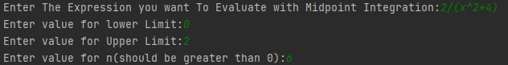

**Output:**

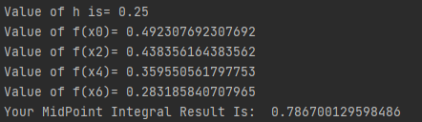

**Verification:**



**Q5d)**

**Input:**

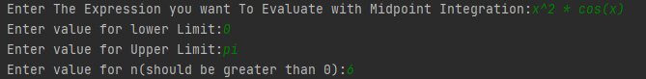

**Output:**

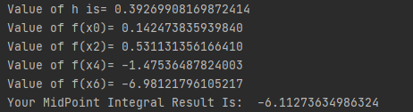

**Verification:**



# **Chapter#5 -Initial-Value Problems for Ordinary Differential Equations**

## Euler’s Method:

**Ex: 5.2**



**Inputs:**

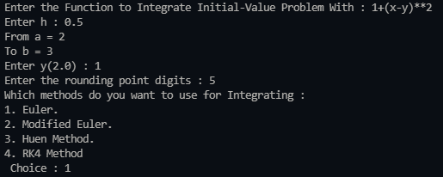

**Output:**

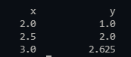

**Verification:**

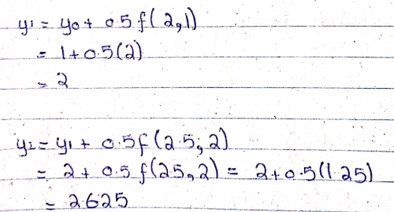

**Ex: 5.2**

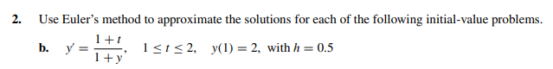

**Inputs:**

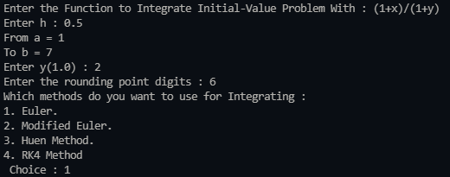

**Outputs:**

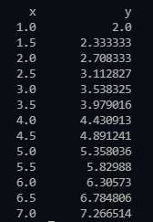

**Verification:**

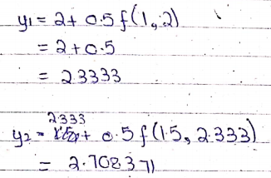

## Modified Euler:

**Ex: 5.4**

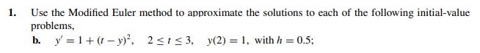

**Inputs:**

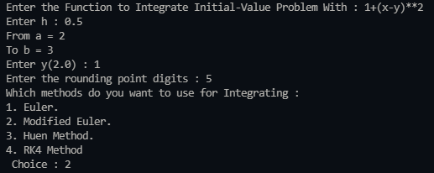

**Output:**

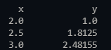

**Verification:**

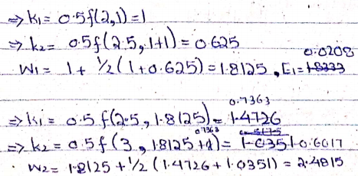

**Ex: 5.4**

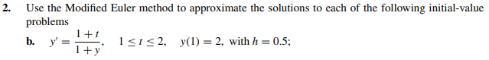

**Inputs:**

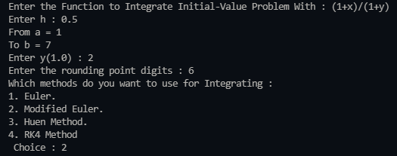

**Outputs:**

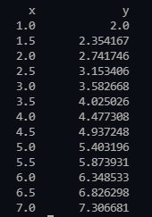

**Verification:**

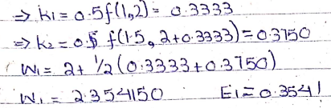

## Huen Method:

**Ex: 5.4**





**Input:**

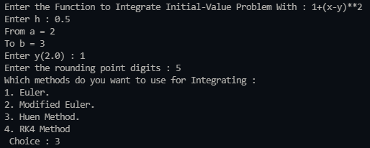

**Output:**

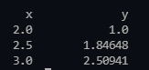

**Verification:**

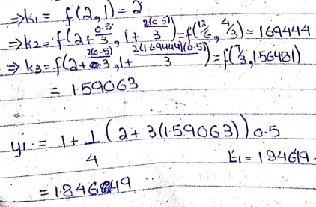

**Ex: 5.4**





**Inputs:**

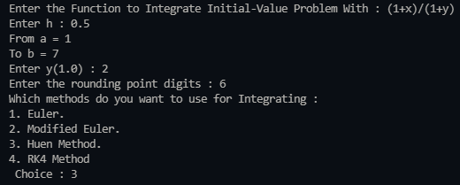

**Output:**

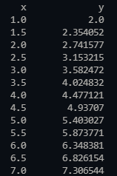

**Verification:**

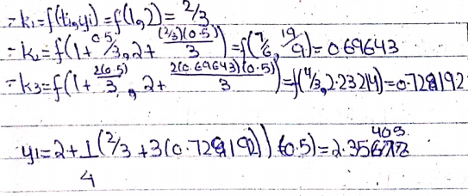

## RK4 Method:

**Ex: 5.4**





**Inputs:**

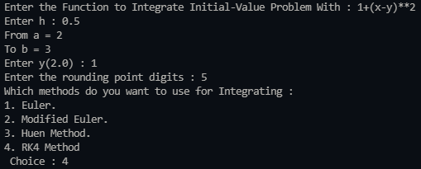

**Output:**

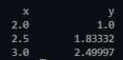

**Verification:**

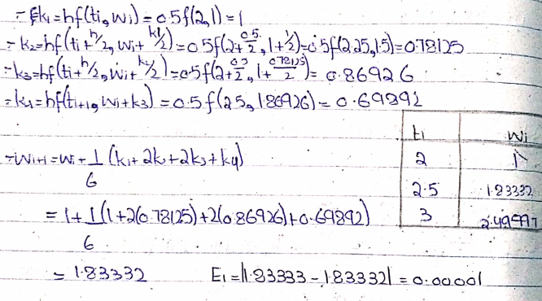

**Ex: 5.4**





**Inputs:**

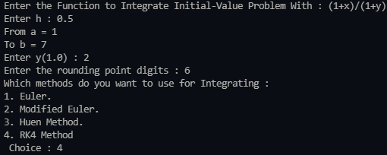

**Output:**

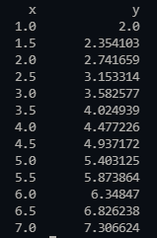

**Verification:**

